Redirection operators > , >> , <

Command:
man : dictionery
mkdir : create directory
rmdir : remove direcoty
ls : List of directory
cd : change directory
cat > : create file
cat >> : update file
cat < : check file
touch : create empty file
rm : delete file
rm -rf : forcefully delete file, content, direcoty
pwd : Present working directory

Below Screenshot

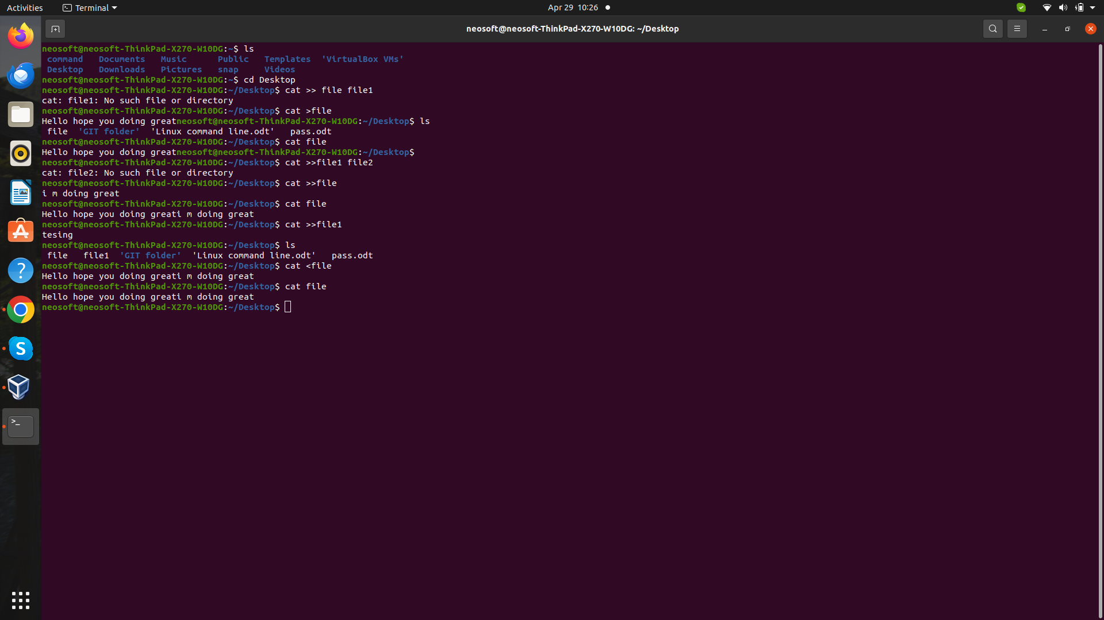

Find

find . -name *** : find the path of folder (locate)
find . -type f -name *** : we can check the file path
find . -type d -name *** : we can checkthe diretory path

locate

To run locate command need to install mlocate or plocate (sudo apt install mlocate)

locate *** : find the location of file
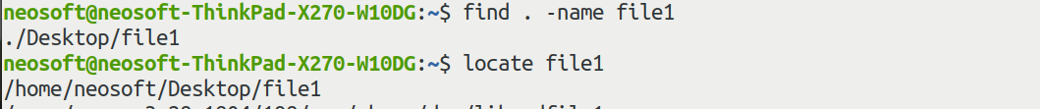

grep , tail , Pipe (|) , more , less

Grep
grep “XYZ” *** : nothing but its like filter or pattern for search in particular file
1. grep -c “xyz” *** : count of words or alphabhet will show
2. grep -h “xyz” *** : display all matching words or alphabhet

Pipe
cat *** | grep “XYZ” : Its same like a filter
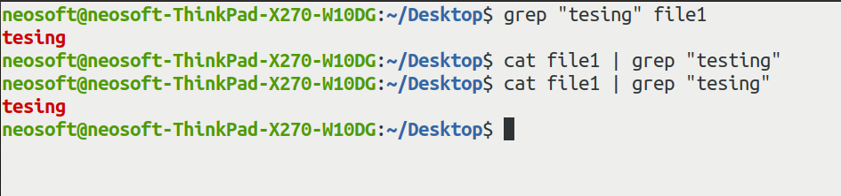

Tail and Head

tail *** : Its display last 10 line
tail – 5 *** :Its shown last 5 line
head *** : Its display starting 10 line
tail – 5 *** :Its shown last 5 line

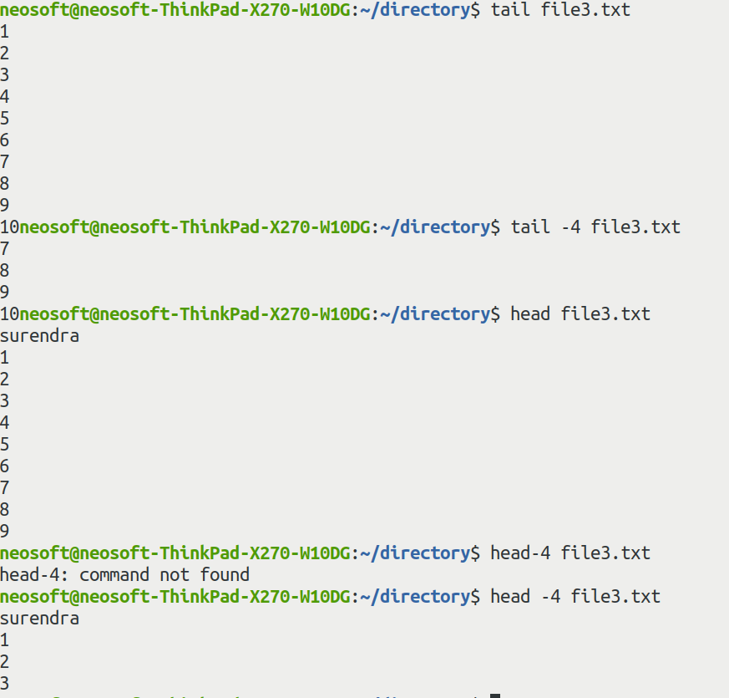

More or less
more *** : view all content ( forward )
less *** : view less content (forward and backward )
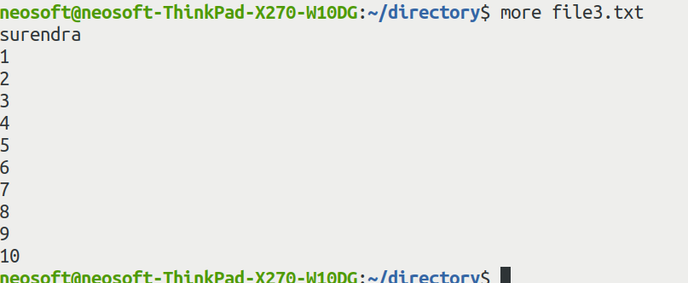

Sed ( stream editor )

sed ‘s/Mumbai/delhi/’ *** : cmd is user for replace the word (edit)

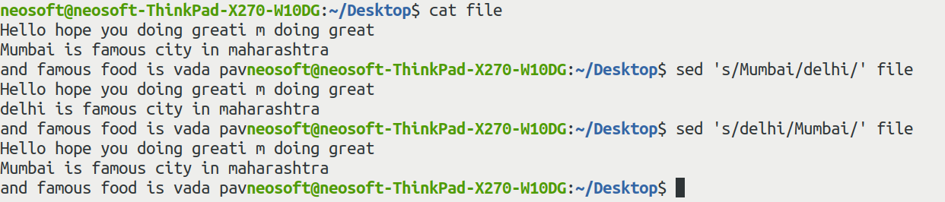

Telnet ( check connectivity of any website )
telnet google.com : we can check port is accessable or not
telnet ip port
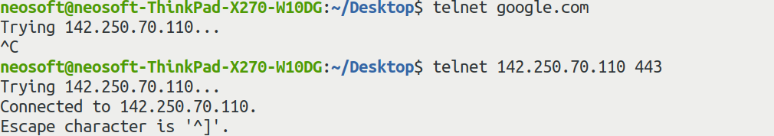

htop : Use to check task manager
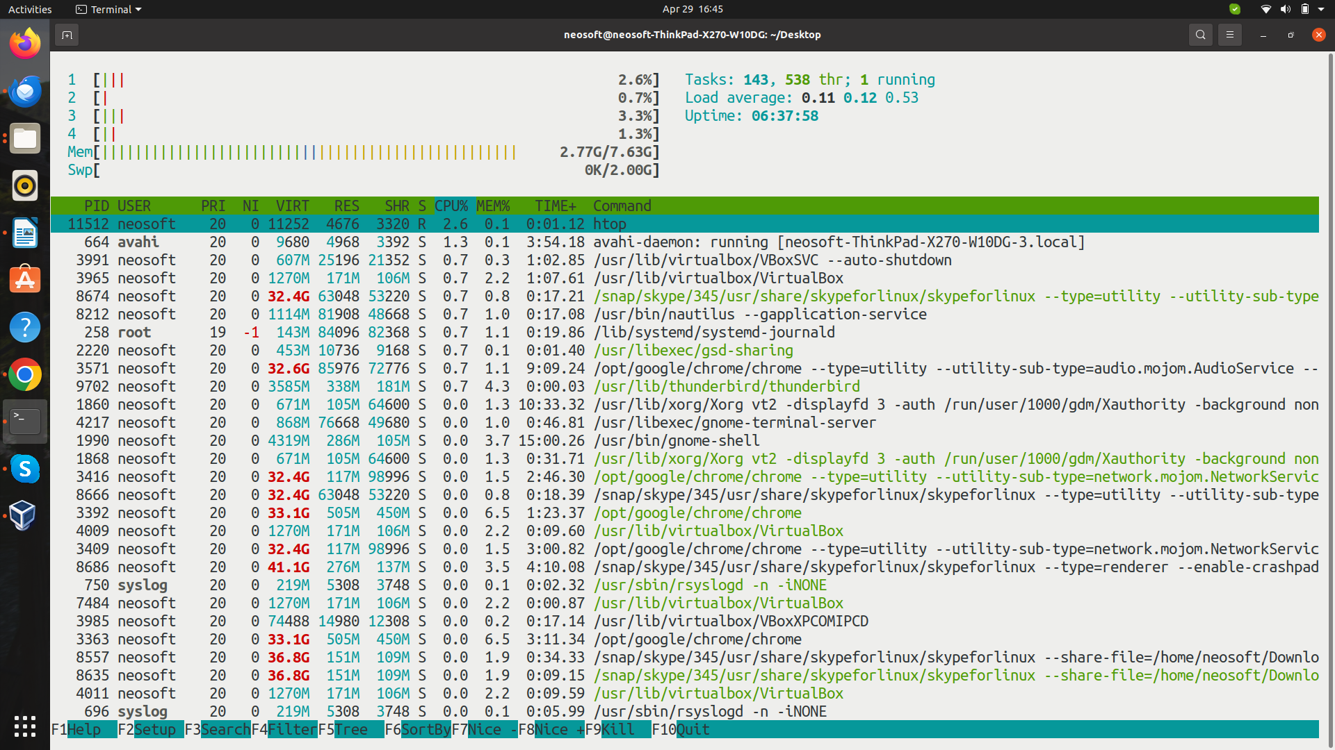
sudo iotop : disk read and write (input/output)
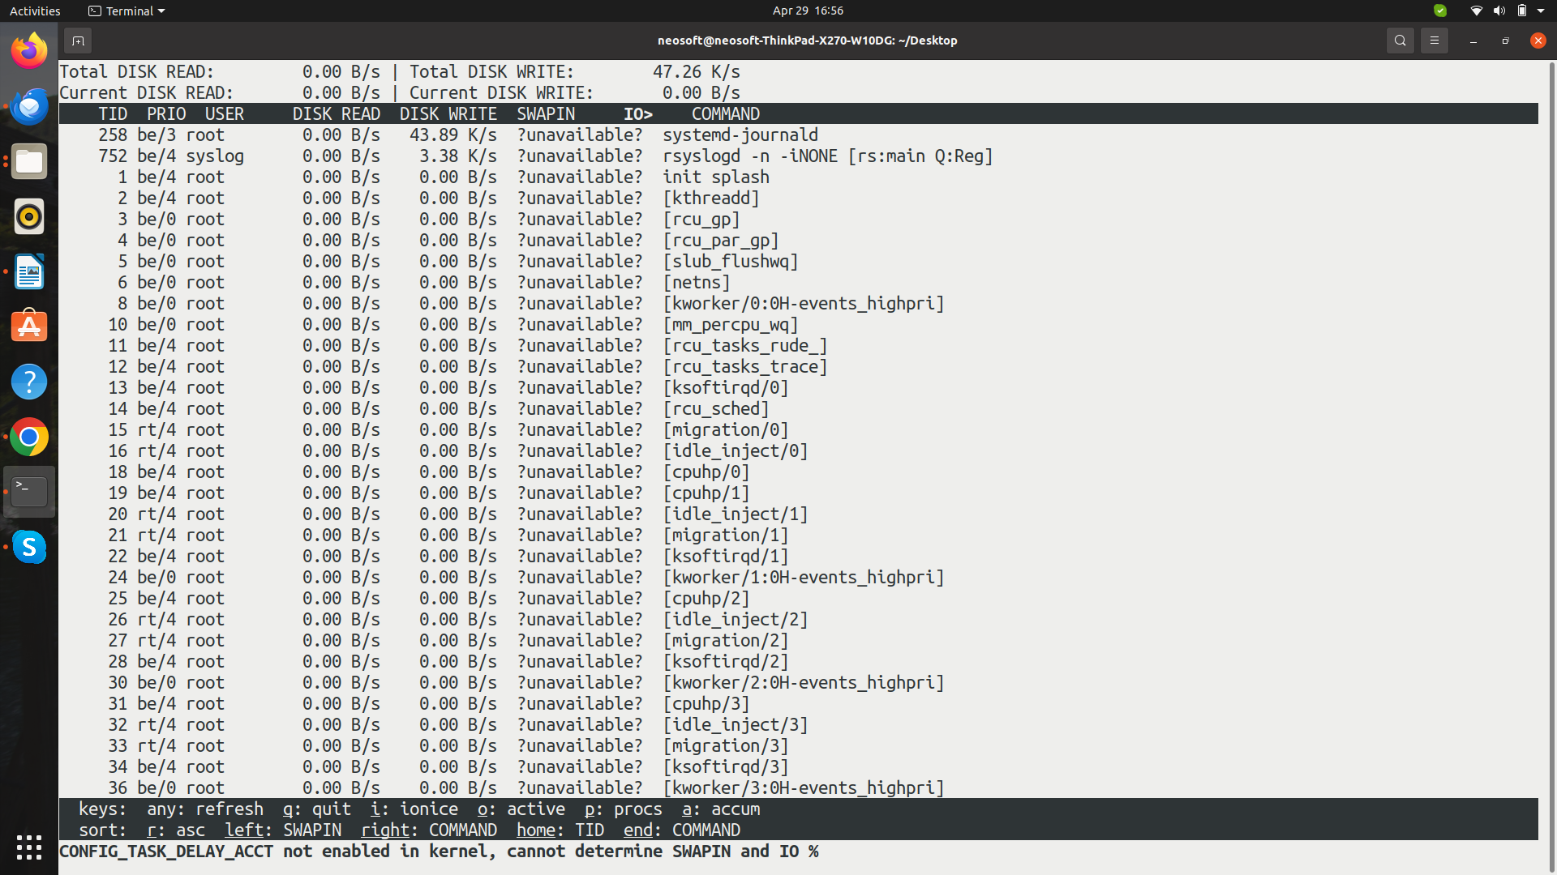
df -h : to check the used of disk
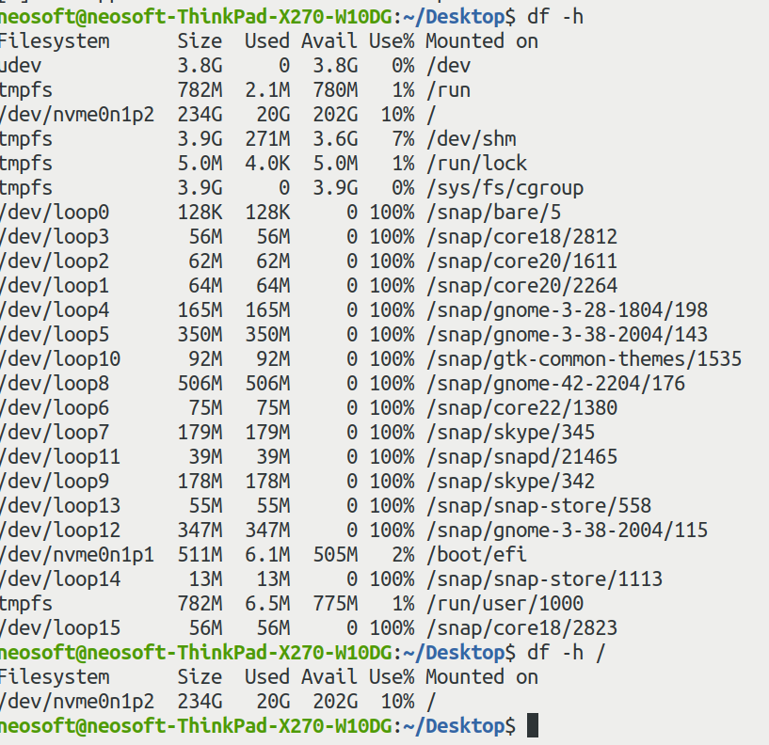
du -h *** : check file size
du -all : check all file size on that directory
